**ShopNest Power -BI Capstone Project**

**Introduction**

ShopNest stands as the leading department store in the e-commerce marketplaces in Portugal. Serving as a seamless link, it connects small businesses from various regions in Portugal to channels, streamlining the process with a single point of contact. Through the ShopNest Store, these merchants can showcase and sell their products, with the added convenience of direct shipment to customers facilitated by ShopNest logistics partners.

The data presented in this report has been anonymized while providing accurate market insights. Through a comprehensive analysis and visualization, stakeholders gain a clear understanding of market dynamics, enabling informed decision-making. This report is structured to guide you through key aspects of the ShopNest departmental store, concluding in actionable insights displayed on the interactive Power BI dashboard.

**Q1.** Identify the rating distribution in the ShopNest dataset, showcasing ratings categorized as Excellent, Very Good, Good, Bad, and Very Bad, along with corresponding orders.

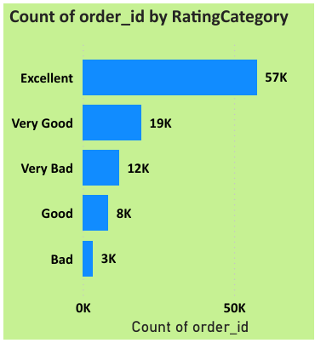

This chart indicates that the majority of customers rated their orders positively, with “Excellent” being the most common rating. This suggests a high level of customer satisfaction overall. However, there are still areas to aim for improvements, as indicated by the “Bad” and “Very Bad” ratings.

**Q2.** What are the top 10 and bottom 18 most popular product categories in the ShopNest dataset? Please list them based on the number of orders.

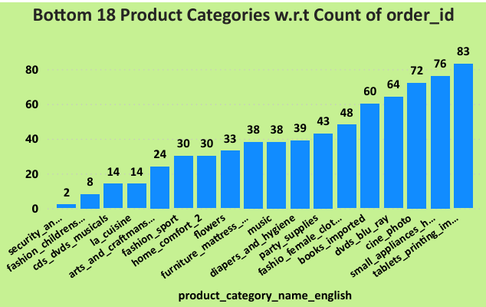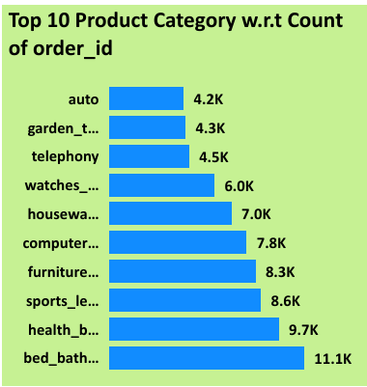

**Top 10 Categories:**

**Bed Bath Table:** This category is the most popular with 11.1K orders, indicating strong demand.

**Health Beauty:** 9.7K orders, suggesting that health and beauty products are in high demand.

**Sports Leisure:** 8.6K orders, making it a significant contributor to overall sales.

Other categories like Housewares, computer accessories, Furniture Decorations etc. are also popular but have slightly lower orders which is still indicating significant consumer interest.

**Bottom 18 Most Popular Product Categories**

**Security and services:** With only 2 orders, this category is the least popular, possibly due to lack of consumer interest.

**Fashion children’s clothes:** 8 orders indicate low consumer demand in children’s fashion clothing.

**CDs, DVDs, musicales: -** Emergence of online platforms makes it easier to listen to music at will. Thus just 14 orders suggest that this category does not perform well.

Other categories like arts and craftsmanship, fashion sport and home comfort also does not contribute majorly to the revenue stream.

**Q3.** List the total number of active sellers by yearly and monthly.

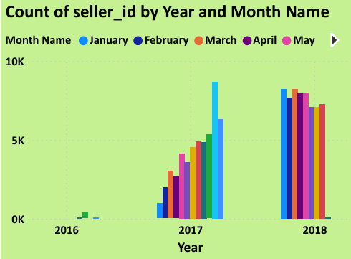

The year 2016 saw the lest number of sellers since it might have been the inception year. But as we move forward to 2017, we can see a signification growth in the number of sellers. Starting at a count of mere 955 sellers in the month of January, 2017, the growth went up to 6308 in the month of December. However, the main spike in sellers was observed to be in the month of November which constituted 8665 for that month.

In 2018, the minimum seller count remained above 7000 consistently through January till August which can be considered as a good sign since the number has not dropped to the average of the previous year. This indicates good performance of the store in terms of sales and logistical operations.

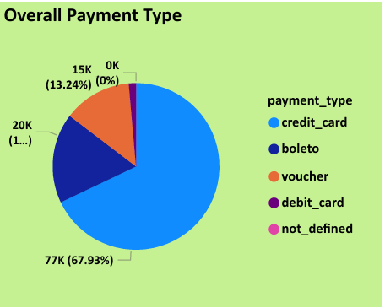**Q4.** Which payment methods are most commonly used by ShopNest customers?

**Credit Card:** 73.92% of transactions are made using credit cards, showing that this is the preferred payment method for customers.

**Boleto:** 19.04% usage indicates local payment method convenience in those regions.

**Voucher:** 5.56%, a smaller percentage, indicating limited use, perhaps due to less promotions or discounts with the **Debit cards** being the least used.

Overall, the above insights inform us about the customer behavior and financial of the particular region. Partnering with banks along with good sales and strategy can go a long way in maintaining the cash flow into the company.

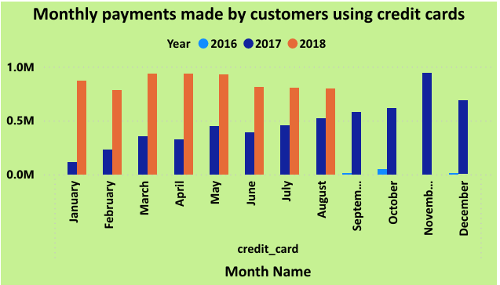**Q6)** Determine the monthly payments made by customers using credit cards.

In year 2016 most of the payments are made in the month of October only.

In the year 2017, the trend of credit card payments exhibited a notable seasonal pattern. Our analysis reveals that **November** was the peak month for credit card transactions, with the highest payment volume recorded. This surge in payments could be attributed to end-of-year events, holiday shopping, or special promotions that drive increased consumer spending. Conversely, the first part of the year, spanning from **January to April**, saw the lowest levels of credit card payments. This decline in payments during these months could be linked to post-holiday financial recovery or a seasonal dip in consumer spending.

This seasonal variation in payment trends highlights the impact of annual events and economic factors on credit card usage patterns. Understanding these trends can help in planning marketing strategies and managing financial resources more effectively.

The year 2018 displayed a distinct pattern in credit card payment behaviour. During the months of **April, May, and June**, payments remained relatively stable, indicating a period of consistent

consumer spending. This steady trend suggests that these months did not experience significant fluctuations in payment volumes, potentially due to a balanced consumer spending pattern or the absence of major financial events. In contrast, **February** and **August** saw noticeable declines in credit card payments. The decrease in February might be attributed to post-holiday financial adjustments or the natural dip in consumer spending after the festive season. Similarly, the drop in August could be related to the summer vacation period, during which spending patterns often change.

**Q5)** Identify the product category. wise profit margin using the formula:

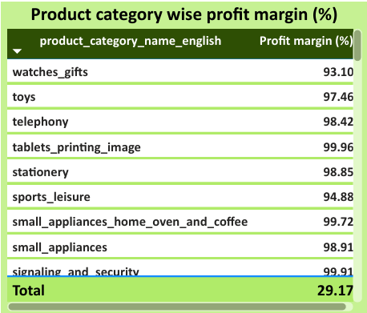Hint: (Payment value -price + Freight_value)/payment_value*100 (Rounded to two decimal points).

Overall profit margin stands at 29.17%.

**Q7)** Identify sellers categorized by city, excluding cities starting with the letters S and B.

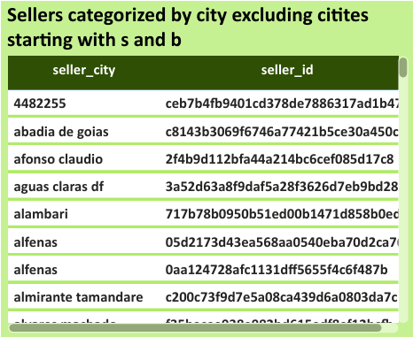

Overall a count of 1790 sellers categorized by city has been found whose names does not start with s and b.

**Q8)** Create a dynamic visual that compares the number of delayed orders to the number of orders received earlier for each month. Utilize the drill through the cross-report feature to provide a detailed analysis of late and on-time deliveries.

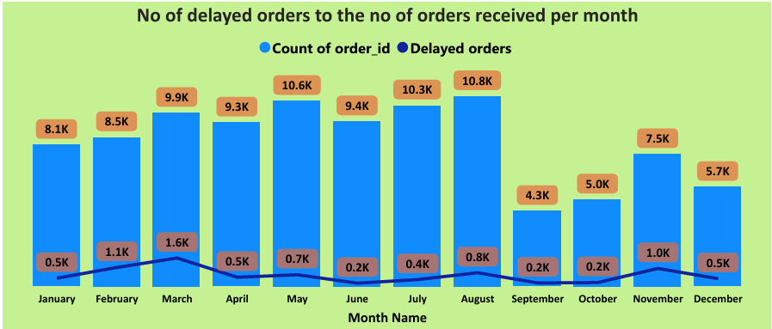

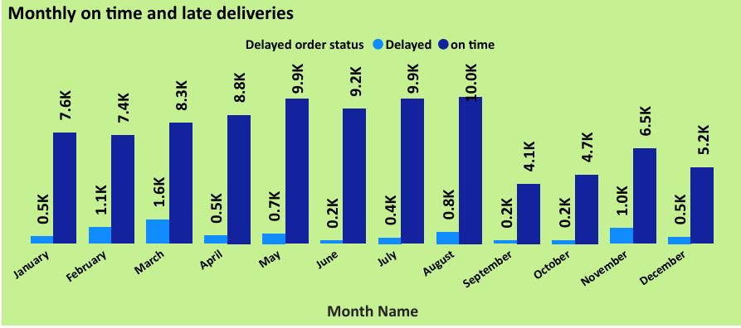

The no of delayed orders is on a average around the 0.5k mark. However, during the month of February, March and November there are spike seen in the delayed orders. The spikes jumped above 1k mark in those months. Holidays and seasonal changes can be a cause for those spikes which can cause issue with the supply chain thus hampering the delivery process as well. Rest of the year a stable trend can be seen which suggests a smooth operational functionality of the logistical operations of the ShopNest e-commerce stores.